HOW TO: Recycled Tin Lantern
Celebrate Trees in the Rigging: A Community Carol Sing and Boat Parade with these homemade, punched-tin lanterns created from recycled cans. The tiny holes will create gorgeous scattered light patterns on the sidewalks of Main Street at this festive event.

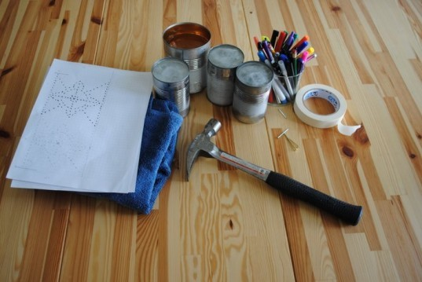

STEP 1: GATHER YOUR MATERIALS
- 2-4 cleaned, empty tin cans (you can use any size)
- a hammer
- an assortment of nails (for larger or smaller holes)
- colorful permanent markers
- paper, pencil, masking tape, scissors (if you plan to use a pattern)
- votive candles (LED work best)
- a towel

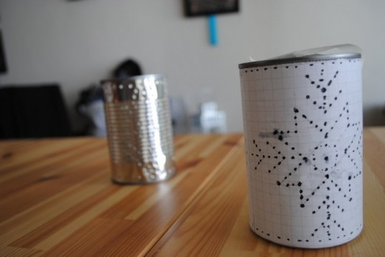

STEP 2: CLEAN AND FREEZE
Remove labels from cans and clean thoroughly. Fill each can with water and freeze overnight until solid. The ice stabilizes the cans and prevents them from bending when holes are punched in them later.
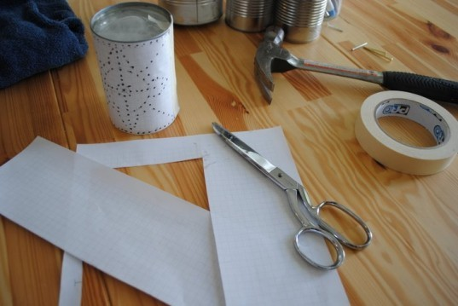

STEP 3: DESIGN YOUR PUNCH GRAPHIC
Decide on a design for your punched-tin decorations. You may draw the pattern ahead of time on a piece of graph paper and tape it to the can as a guide. You can also freehand a design without marking it ahead of time. Knitting patterns, wallpaper, textiles, and folk art are all great inspiration sources for patterns!

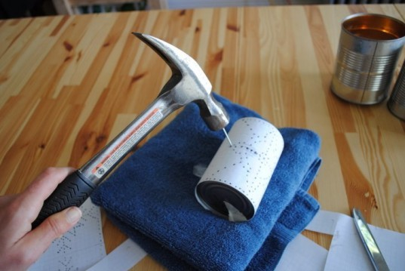

STEP 4: PUNCH OUT YOUR PATTERN
Place the frozen tin can on a folded towel (to prevent the can from moving and to catch ice chips). Position a sharp, narrow nail above each mark on your pattern and gently tap it 3-4 times with the hammer until just the point has punched the tin can. Repeat for each mark until you have completed your pattern.
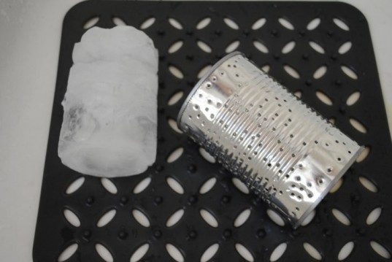

STEP 5: REMOVE THE ICE
Rinse the can under warm water until the ice pops out. Let the can air dry.

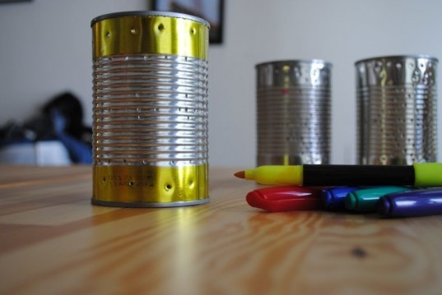

STEP 6: ADD SOME COLOR
If you want to add color to your new punched-tin lantern, you can create a variety of fun, shiny designs by simply using colorful permanent markers.

STEP 7: LET THERE BE LIGHT!
Drop in some lighted votive candles and enjoy the fun, flickering patterns cast by your new handmade lanterns! Be sure to place the lanterns on a fire-safe surface as the candles can get hot.

